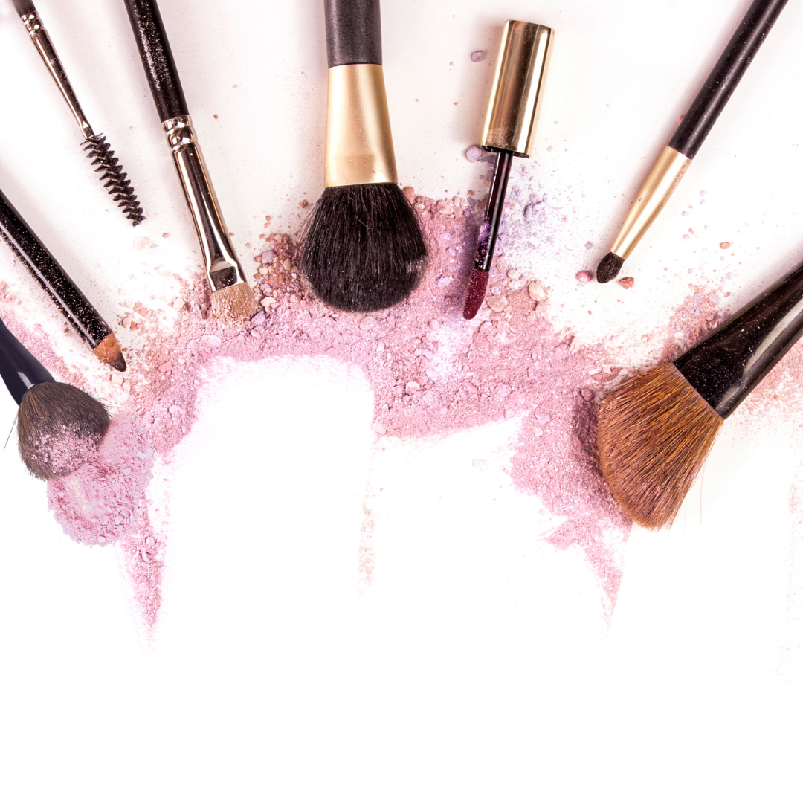

**Makeup Price List**

**Make Up**

Cleanse, Makeup & Lashes ……………………… $00

Cleanse & Makeup …………………………………. $00

Make-up Lessons……………………………….……. $00

**Wedding**

Bridal Makeup Trial ………………………………… $00

Bridal Makeup Package…………………………… $00

Bride Updo ………………….…………………………… $00

Ultimate Bridal Entourage Package ………… $00

**Eye Care**

Eyebrow Wax & Shape..…………………………… $00

Eyebrow Tint……………….…………………………… $00

Eyelash Tint……………………………………………… $00

Full Set of Lashes……………………………………… $00