

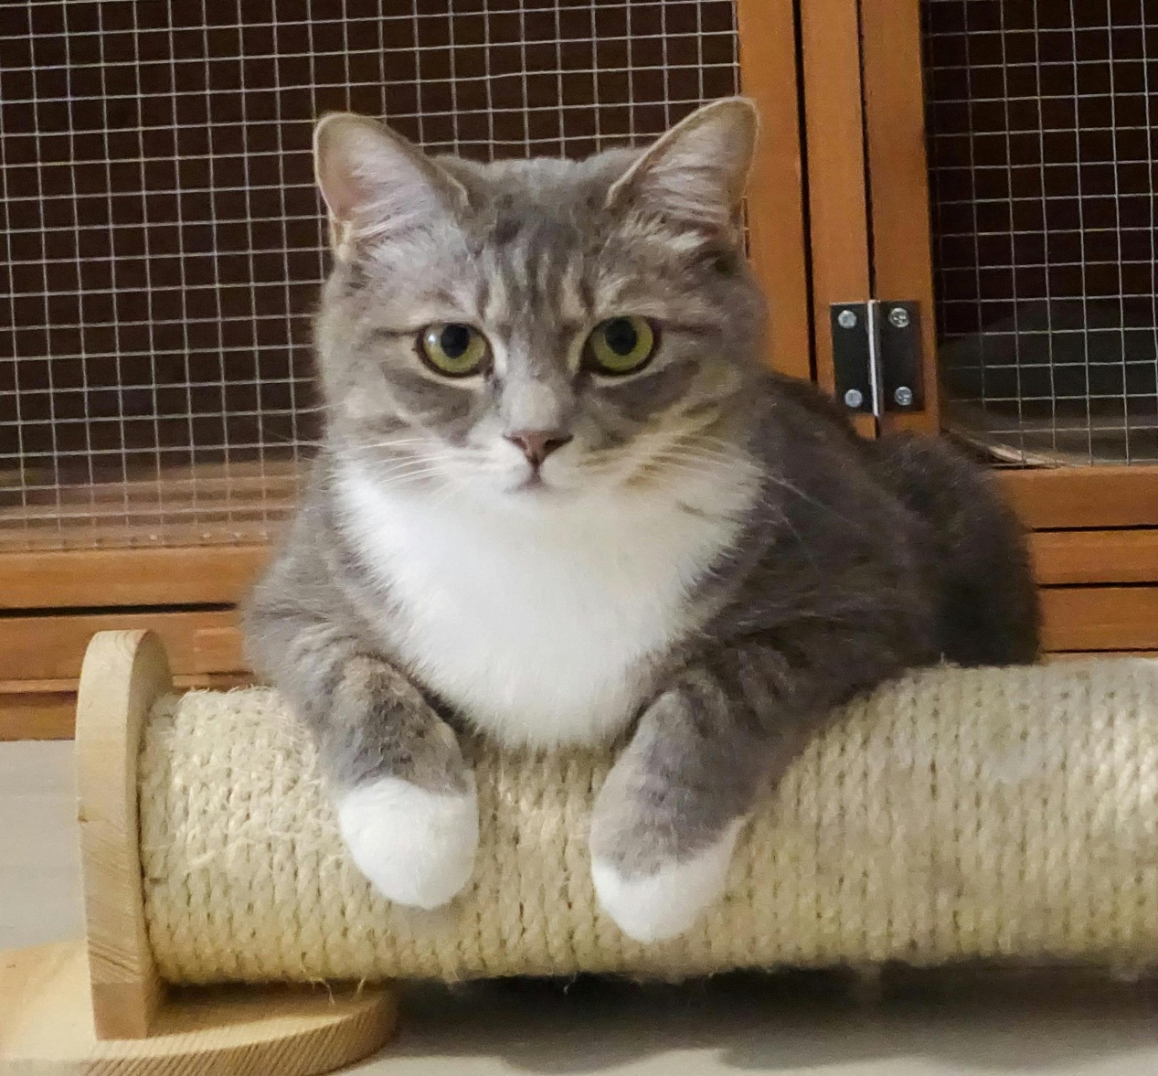
[Detail]: __________________________ [Detail]: ________________________
[Detail]: __________________________ [Detail]: ________________________
[Detail]: __________________________ [Detail]: ________________________
[Detail]: __________________________ [Detail]: ________________________

Last Seen at: _________________ On: ___________________
Name: ______________________
Please Call: +1 234 56 789

